North Western University



Project Title: College Network Scenario

Course Title: Computer Networking Sessional

Course code: CSE-3304

|  |  |
| --- | --- |
| Submitted by:  Name:Sajib Bhattacjarjee  ID:20201070010  Department of CSE  North Western University, Khulna. | Submitted to:  Name: Abu Naim Khan  Lecturer,  Department of CSE.  North Western University, Khulna. |

Remarks:

**Executive Summary**

Different users are there for the project; the users are present in different groups at different places. By this, a request is induced by one of the other users to interface with other user/users or share some data with them. There can be a condition where a message is to be broadcasted to the entire college by a user. So this paper is about communication among divergent users present at different sites, sharing this common network. CNS Stands for the college network scenario..

The wireless network is one of the important components of a digital campus and a wisdom campus. It provides an efficient way to explore the internet with a mobile terminal for teachers and students regardless of cables and places. This is an important mark of the modern campus as a supplement to a cable network. With the development of network and communication technology, cable networks on a university campus bring much convenience for teaching and research work. But for mobility and flexibility, it has obvious shortcomings. A wireless network can overcome these drawbacks and has been applied to the university campus.

In this mini-project, we defined a simulation of campus networks based on wireless networking. The network is divided into two sets: one for the campus area and the other for the hostel area.

The major aim of this project is to show the wireless connectivity that is used in universities to make the network efficient and mobile at the same time. Mobility is the major concentration of this project. In order to provide equal functionality to all the users (college staff and students), we have added DNS, Email, and HTTP servers for the maximum utilization of resources.

Hence the campus network provides different services such as connecting the user to the internet, data sharing among users (students, teachers, and different university members), and accessing different web services for different functionalities, so it needs wireless networking for smooth processing.

**Table of Contents Page No.**

**1. Introduction**

1.1. Goals and Objectives of the project 03.

1.2. Terms, Acronyms, and Abbreviations Used 04.

**2. Description**

2.1. Details Explanation 04.

2.2. Technology, software, and hardware used 05.

**3. Discussion 06.**

**List of Figure Page No.**

**List of Tables 04**

We did not use any table in my project.

**1. INTRODUCTION**

1.1. Goals and Objectives of the project

Packet Tracer is a cross-platform visual simulation tool designed by Cisco Systems that allows users to create network topologies and imitate modern computer networks. The software allows users to simulate the configuration of Cisco routers and switches using a simulated command-line interface. Packet Tracer makes use of a drag-and-drop user interface, allowing users to add and remove simulated network devices as they see fit. The software is mainly focused on Certified Cisco Network Associate Academy students as an educational tool for helping them learn fundamental CCNA concepts. Previously students enrolled in a CCNA Academy program could freely download and use the tool free of charge for educational use.

Computing devices are electronic devices that take user inputs, process the inputs, and then provide us with the end results. These devices may be Smartphones, PC Desktops, Laptops, printers, and many more.

The simulations of our network topology can be easily achieved using a cisco packet tracer. Using a simulation mode, you can see packets flowing from one node to another and can also click on a packet to see detailed information about the OSI layers of the networking. Packet Tracer offers a huge platform to combine realistic simulation and visualize them simultaneously. Cisco Packet Tracer makes learning and teaching significantly easier by supporting multi-user collaboration and by providing a realistic simulation environment for experimenting with projects.

**1.2. Terms, Acronyms, and Abbreviations Used**

Abbreviations

CNS, CCNA, CISCO, IP, ROUTER, VLAN

**2.1 Detailed explanation.**

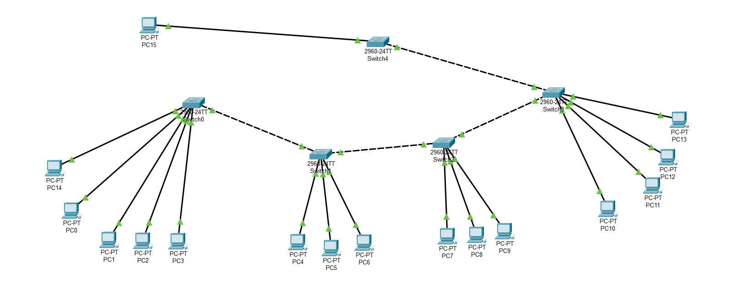

**Fig name: College Network Scenario**

This College Network Scenario is about designing a topology of a network that is a LAN (Local Area Network) for a College in which various computers of different departments are set up so that they can interact and communicate with each other by interchanging data. To design a networking scenario for a college that connects various departments to each other’s, it puts forward communication among different departments. CNS is used to design a systematic and well-planned topology, satisfying all the necessities of the college (i.e. client). CNS come up with a network with good performance. CNS is also providing security and authentication to forbid unauthorized logins.

CCNA: Cisco Certified Network Associate. CCNA is a well-liked certification in computer networking that is developed by Cisco Systems. CCNA is discovered by Cisco, to identify basic capability in the installation and maintenance of medium-sized networks. The technology is used for connecting various devices like routers, switches, and different end devices to communicate with each other and interchange data. Constructing a methodical and reliable network is scalable too. Portability is one of the characteristics of this work application of the CNS.

This job with respect to the College’s Networking Scenario is to provide systematic, secure, valid, and dependable communication among different departments. The work is done keeping in mind the complexity and cost factor. Various departments can simply divide the required data without any problem and can exchange their data without going to them physically, for example a phone call, thus conserving energy and time.

An IP address is a numerical tag assigned to each device (e.g., computer, printer, etc.) taking part in a computer network that uses the Internet Protocol for any communication. It is a 32-bit number. One is IPv4 and the other is IPv6. IPv4 is of 32 bit and is represented as X.X.X.X i.e. each octet is parted by a dot. For e.g.: 191.157.2.2 .In this project IPv4 is used. The assignment of IP address is reliant upon the number of hosts existing in the network. Depending on the number of hosts present in the college; for this network, the IP to be used is a class B IP address i.e. 172.16.0.0 with a subnet mask of 255.255.0.0. And this IP is then distributed among different VLANs and ports for communication. The larger IP is fragmented into smaller networks by using the idea of VLSM (Variable Length Subnet Mask). Variable Length Subnet Masking (VLSM) - is a method that permits network administrators to divide an IP address space into subnets of different sizes. VLSM is the breaking down of IP addresses into subnets (multiple levels) and assigning it based on the individual needs of a network.

**2.2. Technology, software, and hardware used**

**Technology:**

-Cisco Packet Tracer

**Software:**

The requirements required in the CNS are as follows:

Operating System: - Microsoft Windows 10.

Adobe Flash Player.

Cisco Packet Tracer

**Hardware Used:**

-Chipset: Intel CORE i5

- Storage:1 Tera Hard Disk, RAM-8GB

- Primary Display: QVGA TFT LCD or larger, 16 Bit color or Better

- Mouse

- Keyboard

**3. Discussion**

To Design the network outlook for the community college network scenario produces the substructure for all other exposure in the service framework such as security of the network, wireless area network, and mobility as well as putting the justification to provide safety and security, operational efficiencies, virtual learning environments, and secure classrooms. This paper describes the network design scenario approved by Cisco, as well as where we can apply this scenario within the various locations of a community college network. Finally, key network foundation services such as switching, routing, multicast, and high availability are given for the full college network scenario.